1. Objectives:

Our project name is Tic-Tac-Toe game. This game is very popular and is

fairly simple by itself. It is actually a two player game. In this game, there is

a board with n x n squares. In our game, it is 3 x 3 squares.

The goal of Tic-Tac-Toe is to be one of the players to get three same

symbols in a row - horizontally, vertically or diagonally - on a 3 x 3 grid.

1. Objectives:

Our project name is Tic-Tac-Toe game. This game is very popular and is

fairly simple by itself. It is actually a two player game. In this game, there is

a board with n x n squares. In our game, it is 3 x 3 squares.

The goal of Tic-Tac-Toe is to be one of the players to get three same

symbols in a row - horizontally, vertically or diagonally - on a 3 x 3 grid.

1. Objectives:

Our project name is Tic-Tac-Toe game. This game is very popular and is

fairly simple by itself. It is actually a two player game. In this game, there is

a board with n x n squares. In our game, it is 3 x 3 squares.

The goal of Tic-Tac-Toe is to be one of the players to get three same

symbols in a row - horizontally, vertically or diagonally - on a 3 x 3 grid.

1. Objectives:

Our project name is Tic-Tac-Toe game. This game is very popular and is

fairly simple by itself. It is actually a two player game. In this game, there is

a board with n x n squares. In our game, it is 3 x 3 squares.

The goal of Tic-Tac-Toe is to be one of the players to get three same

symbols in a row - horizontally, vertically or diagonally - on a 3 x 3 grid.

1. Objectives:

Our project name is Tic-Tac-Toe game. This game is very popular and is

fairly simple by itself. It is actually a two player game. In this game, there is

a board with n x n squares. In our game, it is 3 x 3 squares.

The goal of Tic-Tac-Toe is to be one of the players to get three same

symbols in a row - horizontally, vertically or diagonally - on a 3 x 3 grid.

1. Objectives:

Our project name is Tic-Tac-Toe game. This game is very popular and is

fairly simple by itself. It is actually a two player game. In this game, there is

a board with n x n squares. In our game, it is 3 x 3 squares.

The goal of Tic-Tac-Toe is to be one of the players to get three same

symbols in a row - horizontally, vertically or diagonally - on a 3 x 3 grid.

**Tic Tac Toe Game**

**SYNOPSIS**

SUBMITTEDINPARTIALFULFILLMENTOFTHEREQUIREMENTFORTHE AWARD OF THE DEGREE OF (12pt.)

# BACHELOROFTECHNOLOGY

(CSE)(3rd yr)

SUBMITTED BY

(Shivam Batham - 2100460109003)



# Dr.APJ Abdul Kalam Technical University ,UttarPradesh

# LUCKNOW , INDIA

2022-23

# CERTIFICATE

This is to certify that the Project Report on the topic of “TIC TAC TOE WEBAPPLICATION ” is submitted by SHHIVAM BATHAM CSE 3rd year (2100460109003) in fulfillment for the award of degree of BACHELOR OF TECHNOLOGY in Computer Science and Engineering has

been found satisfactory and is approved for submission.

Embodies the work of the candidates themselves,

Has duly been completed

Is upto the desired standard both in respect of contents and language for being referred to the examiners.

**Dr.Saurabh Singh**

Head of Department

CSE MPEC

## **INDEX**

1. INTRODUCTION
2. OBJECTIVE
3. SOFTWARE & HARDWARE REQUIREMENT
4. FLOW CHART
5. LITERATURE REVIEW
6. TECHNOLOGY USED
7. MODEL REVIEWED
8. OUTPUT SCREENSHOT
9. CONCLUSION
10. RESULT ANALYSIS
11. FUTURE SCOPE
12. REFERENCE
13. APPENDIX
14. CODE SOLUTION

**INTRODUCTION**

This game can be played in a 3x3 grid (shown in figure below) .The game can be played by two players. There are two options for players:

Generally, The Tic-Tac-Toe game is based on having a game board (2D array) of size 3 x 3. The players alternate placing Xs and Os on the board until either one has placed three Xs or Os in a row horizontally, vertically, or diagonally; or all nine board squares are filled. The player wins if s/he draws three Xs or three Os in a row. Otherwise, the game is draw.

(a) Human

(b) Human

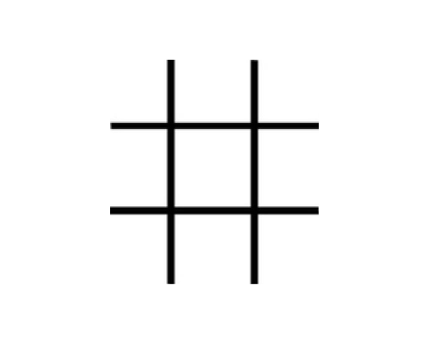

Generally, The Tic-Tac-Toe game is based on having a game board (2D array) of size 3 x 3. The players alternate placing Xs and Os on the board until either one has placed three Xs or Os in a row horizontally, vertically, or diagonally; or all nine board squares are filled. The player wins if s/he draws three Xs or three Os in a row. Otherwise, the game is draw.

**OBJECTIVE**

My project name is Tic-Tac-Toe game. This game is very popular and is fairly simple by itself. It is actually a two player game. In this game, there is a board with n x n squares. In my game, it is 3 x 3 squares.

The goal of Tic-Tac-Toe is to be one of the players to get three same symbols in a row - horizontally, vertically or diagonally - on a 3 x 3 grid.

Generally, The Tic-Tac-Toe game is based on having a game board (2D array) of size 3 x 3. The players alternate placing Xs and Os on the board until either one has placed three Xs or Os in a row horizontally, vertically, or diagonally; or all nine board squares are filled. The player wins if s/he draws three Xs or three Os in a row. Otherwise, the game is draw.

Initially the board grid squares are initialized to zeros. Xs and Os might be denoted by numbers

inside the board grid by ones and twos respectively. I.e. if player one choses X, the location of

that choice is registered as 1 and when player two choses O the location of that choice in your

array is registered as 2. At the end if a row of 1s is registered then player one won the game. Or if a row of 2s is registered thus player two won the game. If not, the game is draw. The game ends when there is no more empty fields in the array (board) to fill or if one of the players wins the game.

2. Overview:

This game can be played in a3x3 grid (shown in the figure 2.1) .The game

can be played by two players. There are two options for players:

(a) Human (b) Compute

**SOFTWARE AND HARDWARE**

**REQUIREMENT**

**SOFTWARE REQUIREMENT**

1. Laptop
2. VS code studio IDE
3. VS Live server for local hosting
4. OS – windows
5. JavaScript
6. HTML
7. Cast cadding style sheet (CSS)

**HARDWARE REQUIREMENT**

1. Laptop
2. 256 GB SDD
3. Ryzen 3 processor
4. Intel UHD Graphic

2.1 Players:

For the option human, both the players are human and for the option

computer, the first player is human and the second player is computer.

**FLOW CHART**

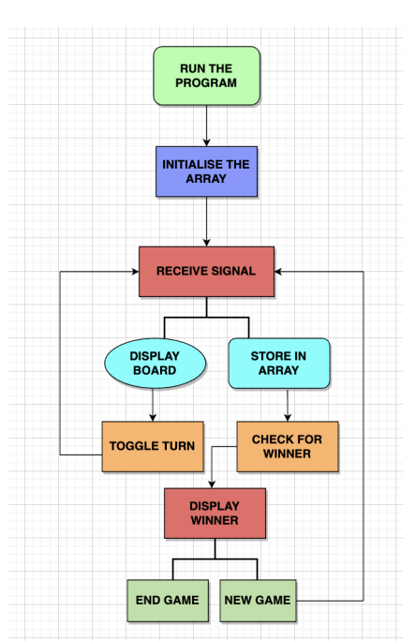

**LITERATURE REVIEW**

We have reviewed the tic-tac-toe research articles and rewrote the findings below.

Tic-Tac-Toe is a straightforward but fun board game. The Tic-Tac-Toe game is learned using a variety of methods. Fok and Ong [3] and Grim et al. [4] For example, they developed strategies based on a neural network of artificial intelligence to play them.

Citrenbaum [5] and Yakowitz [6] discuss games like TicTac-Toe, such as Go-Moku, Hex, and Bridg-It.

Traditionally, the Tic-tac-toe game is a pencil and paper game played by two people taking turns placing their pieces on the 3rd grid with the intention of becoming the first player to complete a horizontal, vertical, or diagonal line. Row with their pieces

Many versions of the Tic Tac game software have been recorded, and have recently been made available on smart phones, including the Apple iPhone [7] and the Android environment [8].

The integrated digital circuit design of Stephen Mann and Matthew Netsch [9] to perform neural network (NN) calculations to explore the Tic-Tac-Toe area was presented. By literally mapping the routes between sensible gates on each chip, FPGAs can create modern digital designs.

Shahzeb Siddiqui et al [10] has used another NN application that extends the game by adding two new lines, two additional columns, and a third dimension. The paper lists the best place to use the concept of developing a neural network that combines the spread of backpropagation combined with parts of the genetic algorithm to improve the chances of finding the best solution and highlighting our methods of use.

Pinaki Chakraborty [11] officially created the Tic-Tac-Toe game and created its own creative techniques based on artificial intelligence. By allowing the high-pitched voice of the classic movement, Leaw and Cheong [12] made a modest imitation of the old tic-tac-toe game.

Edward [14] uses an optically subjugated gate array (OPGA) to demonstrate the efficiency of electrooptical circuits that incorporate human input, display, and sensible power into a single device using a simple Tic-tacttoe game. There are additional updates on route strategies, designs, and logical simulations.

Alauddin [15] introduces the hardware introduction of the smart Tic-Tac toy. Graphical Liquid crystal display (GLCD) touch screen and small controls are used for operation. The small controller accepts player movement on the GLCD (shown as X) and analyzes it using a sophisticated algorithm to determine the best calculation action. The next opposing movement is printed on the screen by a small circle (O).

Tic Tac Toe is a two-person game, as described by Agustia.M and Amri.P [16], in which one player represents the opposite (o) and the other player demonstrates the opposite (x). The participant draws nine grids on a piece of paper or anywhere else he or she likes. This is a game where two players draw crosses and circles in one compact grid compartment with nine spaces; the goal is to get a line of three crosses or three circles before your opponent.

**TECHNOLOGY USED**

**WEB - TECHNOLOGY**

**HTML :** HTML is the standard markup language for Web pages. With HTML you can create your own Website. HTML is easy to learn and easy to use. It is platform-independent. Images, videos, and audio can be added to a web page. Hypertext can be added to the text. It is a markup language.

**CSS :** CSS is the language we use to style an HTML document.CSS describes how HTML elements should be displayed. CSS stands for Cascading Style Sheet.

**JavaScript :** JavaScript is the world's most popular programming language. JavaScript is easy to learn. JavaScript is the programming language of the Web.

All popular web browsers support JavaScript as they provide built-in execution environments. JavaScript follows the syntax and structure of the C programming language. Thus, it is a structured programming language.

It is a light-weighted and interpreted language. It is a case-sensitive language. JavaScript is supportable in several operating systems including, Windows, macOS, etc. It provides good control to the users over the web browsers.

**MODEL REVIEWED**

**Players:**

Both the players are humans.

**Theory of Game:**

A player can choose between two symbols with his opponent, usual games use “X”and “O”. If first player choose “X” then the second player have to play with “O” and vice versa.

A player marks any of the 3x3 squares with his symbol (may be “X” or “O”) and his aim is to create a straight line horizontally or vertically or diagonally with two intensions:

a) Create a straight line before his opponent to win the game.

b) Restrict his opponent from creating a straight line first.

In case logically no one can create a straight line with his own symbol, the game results a tie.

Hence there are only three possible results – a player wins, his opponent

(human or computer) wins or it’s a tie.

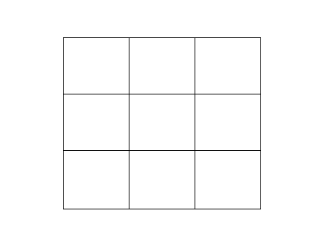

4 5 6   
7 8 9

1 2 3 21212221172 22

Figure.

If any player is able to draw three Xs or three Os in the following

combinations then that player wins.

In this section the Tic-Tac-Toe game will be discussed in details. At the outset, the basic rules of the game are going to be covered.

Then, there will be a review on existing Tic-Tac-Toe games, which in turn will lead to discussion about the existing models of this game and the proposed model of this work.

**The combinations are:**

a) 1, 2, 3 b) 4, 5, 6

c) 7, 8, 9 d) 1, 4, 7

e) 2, 5, 8 f) 3, 6, 9

h) 1, 5, 9 i) 3, 5, 7

**Core Logic - Humans:**

For each move, check whether any 3 combination is occupied by any player

and display the winner accordingly.

**Limitations:**

Only mouse interface is implemented, keyboard is not activated in the

Game.

**OUTPUT SCREENSHOT**

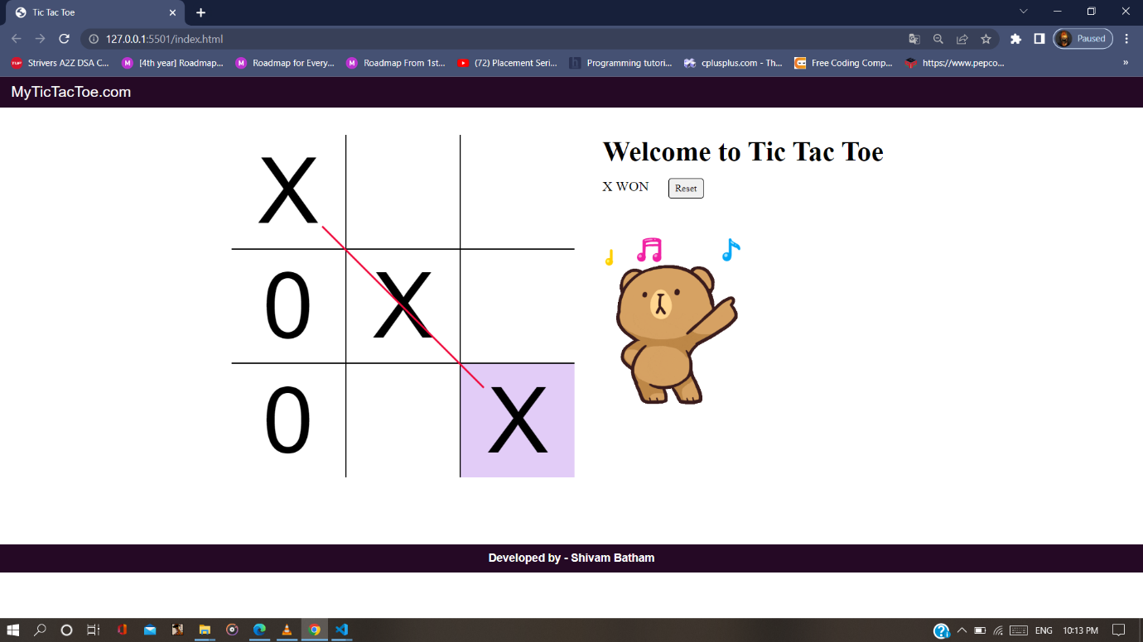

**CONCLUSION**

Conclusion **The Tic Tac Toe game is most familiar among all the age groups**. Intelligence can be a property of any purpose-driven decision maker. This basic idea has been suggested many times. An algorithm of playing Tic Tac Toe has been presented that works in efficient way.

I develop this Tic-Tac-Toe using the javaScript programming language. Tic Tac Toe is a game that is played by people of all ages. It has been developed using the web technology. Any purpose-driven decision maker can have intelligence as a trait. A Tic Tac Toe algorithm has been presented in the system and tested, and it has proven to be effective. Chiefly, the system is free of errors.

**RESULT ANALYSIS**

We have successfully designed a 2-player Tic Tac Toe game in C. As we run the program, the board will be displayed in the following way where it will be shown that player 1 needs to use X and player 2 needs to use 0.

A player can choose between two symbols with his opponent, usual games

use “X”and “O”. If first player choose “X” then the second player have to

play with “O” and vice versa.

A player marks any of the 3x3 squares with his symbol (may be “X” or “O”)

and his aim is to create a straight line horizontally or vertically or diagonally

with two intensions:

a) Create a straight line before his opponent to win the game.

b) Restrict his opponent from creating a straight line first.

In case logically no one can create a straight line with his own symbol, the

game results a tie.

Hence there are only three possible results – a player wins, his opponent

(human or computer) wins or it’s a tie.

**FUTURE SCOPE**

Keyboard functions will be added.

We want to design more complex boards for the game in future

Instead of displaying the output on the website , an attractive Leader Bord can be added to the game .

A login and signup system for storing previous data.

The game can also be equipped with different levels such as easy, medium and difficult.

**Reference**

1)CodeWithHerry.com

2)W3school .com

3) Al-Khateeb, B., Tic-tac-toe evolutionary actor, International Journal of Reasoningbased Intelligent System, Vol. 4, No. 4, pages 182-185, 2012.

4) Garg, R., Nayak, D., Tic-Tac-Toe Game: Simulation using Min-Max Algorithm,International Journal of Advanced Research in Computer Science, Vol. 8, No. 7, pp.1074-1077, 2017.

5) Hochmuth, G., On the Genetic Evolution of a Perfect Tic-Tac-Toe Strategy, Stanford University Bookstore, pages 75-82, 2003.

6) Ling, S., H., Lam, H., K., Play Tic-Tac-Toe using the Genetic Neural Network with Double Transfer Functions, Journal of Intelligent Learning Programs and Applications, Vol. 3, pages 37-44, 2011.

7) Mohammadi, H., Nigel, P., A., Venetsanopoulos, A., Santos, M., Evolving Tic-Tac-Toe. Playing algorithms using Co-Evolution, Interactive Fitness and Genetic Programming, International Journal of Computer Theory and Engineering, Vol. 5, No. 5, pages 797-801, 2013.

8) Pilgrim, A., R., Tic-Tac-Toe: Introductory Specialist Systems for Middle School Students, Summer Computer Science Workshop, pp.340-344, 1995.

9) Sharma, N., Tyagi, S., Atri, S., A Comparative Analysis of Min-Max and Max-Min Algorithms based on the Makespan Parameter, International Journal of Advanced Research in Computer Science, Vol. 8, No. 3, pp.1038-1041, 2017.

10) Von Neumann, J. (1956) The General and Logical Theory of Automata. In: New- man, J.R., Ed.,

11) The World of Mathematics, Vol. 4, Simon and Schuster, New York, 2070-2098.

**APPENDIX**

Tic Tac Toe With a Twist By Boye Akinwande, Andy Bergman, Lizzie Cross, Veronica Tan This program can be used to study the version of tic tac toe where each player bids for the right to move. It finds all the ways to play the game and from these finds the way each player would play if the players are assumed to be playing strategically and according to some goal.

**CODE SOLUTION**

**HTML CODE**

<!DOCTYPE html>

<html lang="en">

<head>

    <meta charset="UTF-8">

    <meta http-equiv="X-UA-Compatible" content="IE=edge">

    <meta name="viewport" content="width=device-width, initial-scale=1.0">

    <title>Tic Tac Toe</title>

    <link rel="stylesheet" href="style.css">

</head>

<body>

    <header>

        <nav>

            <ul>

                <li>MyTicTacToe.com</li>

            </ul>

        </nav>

    </header>

    <div class="gameContainer">

        <div class="container">

            <div class="line"></div>

            <div class="box bt-0 bl-0"><span class="boxtext"></span></div>

            <div class="box bt-0"><span class="boxtext"></span></div>

            <div class="box bt-0 br-0"><span class="boxtext"></span></div>

            <div class="box bl-0"><span class="boxtext"></span></div>

            <div class="box"><span class="boxtext"></span></div>

            <div class="box br-0"><span class="boxtext"></span></div>

            <div class="box bb-0 bl-0"><span class="boxtext"></span></div>

            <div class="box bb-0"><span class="boxtext"></span></div>

            <div class="box bb-0 br-0"><span class="boxtext"></span></div>

        </div>

        <div class="gameInfo">

            <h1>Welcome to Tic Tac Toe</h1>

            <div>

                <span class="info">Turn for X</span>

                <button id="reset">Reset</button>

            </div>

            <div class="imgbox">

                <img src="giphy.gif" alt="excited_Cat">

            </div>

        </div>

    </div>

    <footer>

        <h4>Developed by - Shivam Batham</h4>

        <p></p>

    </footer>

    <script src="script.js"></script>

</body>

</html>

**CSS CODE**

*{

    margin: 0;

    padding:0;

}

nav{

    background: rgb(37,9,37);

    color:#ffff;

    height: 55px;

    font-family:sans-serif;

    font-size:27px;

    display: flex;

    align-items: center;

    padding:0 20px;

}

nav ul{

    list-style-type: none;

}

footer{

    background: rgb(37,9,37);

    color:#ffff;

    height: 50px;

    font-family:sans-serif;

    font-size:20px;

    display: flex;

    align-items: center;

    justify-content: center;

    padding:0 20px;

    margin-top: 120px;

}

.gameContainer{

    display: flex;

    justify-content: center;

    margin-top:50px ;

}

.container{

    font-family: sans-serif;

    display: grid;

    grid-template-rows:repeat(3,10vw);

    grid-template-columns: repeat(3,10vw);

    position: relative;

}

.box{

    border: 2px solid black;

    font-size: 8vw;

    cursor: pointer;

    display: flex;

    justify-content: center;

    align-items: center;

}

.box:hover{

    background-color:rgb(226, 204, 247);

}

.info{

    font-size: 25px;

}

.gameInfo{

    padding:0 50px;

}

.gameInfo h1{

    font-size: 2.5rem;

}

.imgbox img{

    margin-top: 30px;

    width: 0px;

    transition: width 1s ease-in-out;

}

.br-0{

    border-right: 0;

}

.bl-0{

    border-left: 0;

}

.bt-0{

    border-top: 0;

}

.bb-0{

    border-bottom: 0;

}

#reset{

    margin: 20px 30px;

    padding: 6px 10px;

    border-radius: 5px;

    cursor: pointer;

    font-family: serif;

}

#reset:hover{

    margin: 20px 30px;

    padding: 6px 10px;

    border-radius: 5px;

    cursor: pointer;

    color: white;

    background: rgb(39, 9, 37);

}

.line{

    background: rgb(240, 12, 62);

    width: 0;

    height: 3px;

    position: absolute;

    transition: width 1s ease-in-out;

}

/* media query */

@media screen and (max-width :800px) {

    .gameContainer{

        flex-wrap: wrap;

    }

    .gameInfo{

        margin-top: 35px;

    }

    .gameInfo h1{

        font-size: 1.5rem;

    }

    .container{

        display: grid;

        grid-template-rows: repeat(3,20vw);

        grid-template-columns: repeat(3,20vw);

    }

    .imgbox img{

        width: 60vw;

    }

}

**JAVA SCRIPT CODE**

console.log("Welcome to Tic Tac Toe")

let music = new Audio("mixkit-playful-10.mp3")

let audioTurn = new Audio("speech On.mp3")

let gameoverMusic = new Audio("tada.mp3")

let turn = "X"

let gameover = false;

//function to change the turn

const changeTurn = ()=>{

    return turn === "X"? "0": "X"

}

//Function to check for a Win

const checkWin = ()=>{

    let boxtext = document.getElementsByClassName('boxtext');

    let wins = [

        [0,1,2,5,5,0],

        [3,4,5,5,15,0],

        [6,7,8,5,25,0],

        [0,3,6,-5,15,90],

        [1,4,7,5,15,90],

        [2,5,8,15,15,90],

        [0,4,8,5,15,45],

        [2,4,6,5,15,135],

    ]

    wins.forEach(e =>{

        if((boxtext[e[0]].innerText === boxtext[e[1]].innerText) && (boxtext[e[2]].innerText === boxtext[e[1]].innerText) && (boxtext[e[0]].innerText !== "")){

            document.querySelector('.info').innerText = boxtext[e[0]].innerText + " WON"

            gameover = true

            document.querySelector('.imgbox').getElementsByTagName('img')[0].style.width = "250px"

            document.querySelector(".line").style.width = "20vw";

            document.querySelector(".line").style.transform = `translate(${e[3]}vw,${e[4]}vw) rotate(${e[5]}deg)`

        }

    })

}

//Game Logic

// music.play()

let boxes = document.getElementsByClassName("box");

Array.from(boxes).forEach(element =>{

    let boxtext = element.querySelector('.boxtext');

    element.addEventListener('click', ()=>{

        if(boxtext.innerText === ''){

            boxtext.innerText = turn;

            turn = changeTurn();

            audioTurn.play();

            checkWin();

            if(!gameover){

                document.getElementsByClassName("info")[0].innerText = "Turn for " + turn;

            }

        }

    })

})

//Add on click Listener to reset button

reset.addEventListener('click',()=>{

    let boxtexts = document.querySelectorAll('.boxtext');

    Array.from(boxtexts).forEach(element=>{

        element.innerText =""

    });

    turn = "X";

    gameover = false

        document.getElementsByClassName("info")[0].innerText = "Turn for " + turn;

        document.querySelector('.imgbox').getElementsByTagName('img')[0].style.width = "0px";

        document.querySelector(".line").style.width = "0vw";

    })